BANCADA

15 Março 2022

Project overview

| **1.1.Scientific and technical quality** |
| --- |
| The proposed project aims at developing **a portable device to collect data from industrial machines to support maintenance operations** with increased flexibility and reduced cost. The concept is currently at TRL 4 (technology validate in lab) and, at the end of the project, this system is expected to be in TRL 7 (system prototype demonstration in operational environment).  The system to be developed will address the needs of maintenance teams in both Textile and Aerospace sectors, by providing a system with rapid deployment and reduced cost, flexible, so that it can be connected in every machine, and providing an easily set-up Digital Twin for the machine. The innovation of our approach is the concept of a **maintenance “portable unit”**, that is not targeted for a specific machine, model, or device, that will collect data to support maintenance operations, securely uploading this data to the cloud, where it can be analyzed by the maintenance team. This unit will comprise a data collection unit (DCU), to which several sensors will be connected, and that will upload the data to a cloud repository, where it can be accessed by the maintenance team.  This will provide reduced capital costs, as **a single kit can be used for many production machines**, avoiding the cost of installing sensorial equipment that is not required on a continuous basis and that would be idle most of the time. Furthermore, it will **allow retrofitting older production machines**, inserting into an Industry 4.0 production logic equipment that has been in operation for several years and was not originally designed with digitalization in mind. The data will be tagged with the machine identification and the collection time, **allowing to create a history to evaluate deviations and applying artificial intelligence algorithms** to identify and predict failures. |
|  |

|  |
| --- |
| **1.2. Innovation potential** |
| The proposed approach focuses on the application of existing technologies to a specific need of productive systems. The **innovation** in our proposal lies in the concept of a **portable device** that can be attached to any production line machine and collect the data for maintenance purposes (either preventive, predictive or corrective). This approach **will reduce capital costs** by having a “floating” unit that can be attached to different machines, instead of having data collection equipment permanently attached to all the machines. Following this flexible approach, our solution **will address all types of maintenance activities**, not being focused on a specific kind of activity. Currently existing solutions are focused in specific types, such as corrective (<https://www.infraspeak.com/>) or predictive (<https://www.fracttal.com/en/>).  **State of the art:**  A study carried out in Finland assesses that equipment maintenance costs represents, on average, about 5.5% of the company's profits. However, this ratio can vary for extreme efficiency situations, reaching around 0.5% of profits, or even situations of serious inefficiency, reaching around 25% of the company's profits [1]. Another study also revealed that this value can impact production costs ​​of around 60% [2].  Despite the many advances that industrial maintenance has had over the last few years, companies still have many challenges ahead, such as, the lack of communication and information, lack of measurement and control of performance parameters, increased complexity of systems, among others [3].  **Some innovations:**  - **Emergence of new maintenance concepts**. Initially, maintenance was performed correctively, that is, once the problem was detected, it was fixed. New concepts have emerged such as predictive maintenance, which uses software to monitor, analyze and predict failures before they occur. These tools are usually proprietary, and the machine manufacturers themselves develop these tools, "forcing" a company with different machines from multiple manufacturers to have multiple licenses and software to use these tools.  - Appearance of **new technologies and software** for corrective, preventive and predictive maintenance, such as **vibration monitoring and analysis**.  This product will complement PP3’s portfolio on Industrial Automation solutions and it will contribute to improve the operational profitability of PP1 and PP2, by supporting all maintenance operations in an integrated and more economical way.  ————  [1] - Komonen K. A cost model of industrial maintenance for profitability analysis and benchmarking. International Journal of Production Economics.  [2] - Brettel M, Friederichsen N, Keller M, Rosenberg M. How Virtualization, Decentralization and Network Building Change the Manufacturing Landscape: An Industry 4.0 Perspective. International Journal of Mechanical, Aerospace, Industrial, Mechatronic and Manufacturing Engineering.  [3] - Singh RK, Gupta A, Kumar A, Khan TA. Ranking of barriers for effective maintenance by using TOPSIS approach. Journal of Quality in Maintenance Engineering. |
| **1.3 Feasibility of the project** |
| The main objective of the project is to integrate the different types of maintenance in a single application maximizing the potential of each of the maintenance types that can be adopted. This will result in the reduction of maintenance costs, reduction of component degradation and increasing their longevity, thus improving the company's sustainability. It will also have an impact on the operational performance of production equipment. This type of solution will also allow companies to integrate these new concepts and technologies at a lower cost, since there's no need for every equipment to have the hardware permanently installed in the machine.  By digitizing the most relevant physical quantities in the equipment of the textile and aerospace industry, it will allow them to be studied and analysed, enabling the characterisation of type patterns through AI algorithms and Deep Learning, in the identification and prevention of breakdowns.  The use of the "mobile diagnostic/intervention bench" will allow to perform a quick, complete intervention: Mechanical, Electrical, Pneumatic and Hydraulic, relating the different technical areas, digitalising the variables, characterising the breakdown and analysing the evolution of the physical magnitudes until the breakdown occurs. |

General Notes

 IFM/SmartObserver:

<https://www.ifm.com/pt/pt/applications/070/tecnologia-de-automacao-confiavel-para-a-industria-de-mineracao.html#!/content/documents/pt/shared/applications/070/1010/1010>

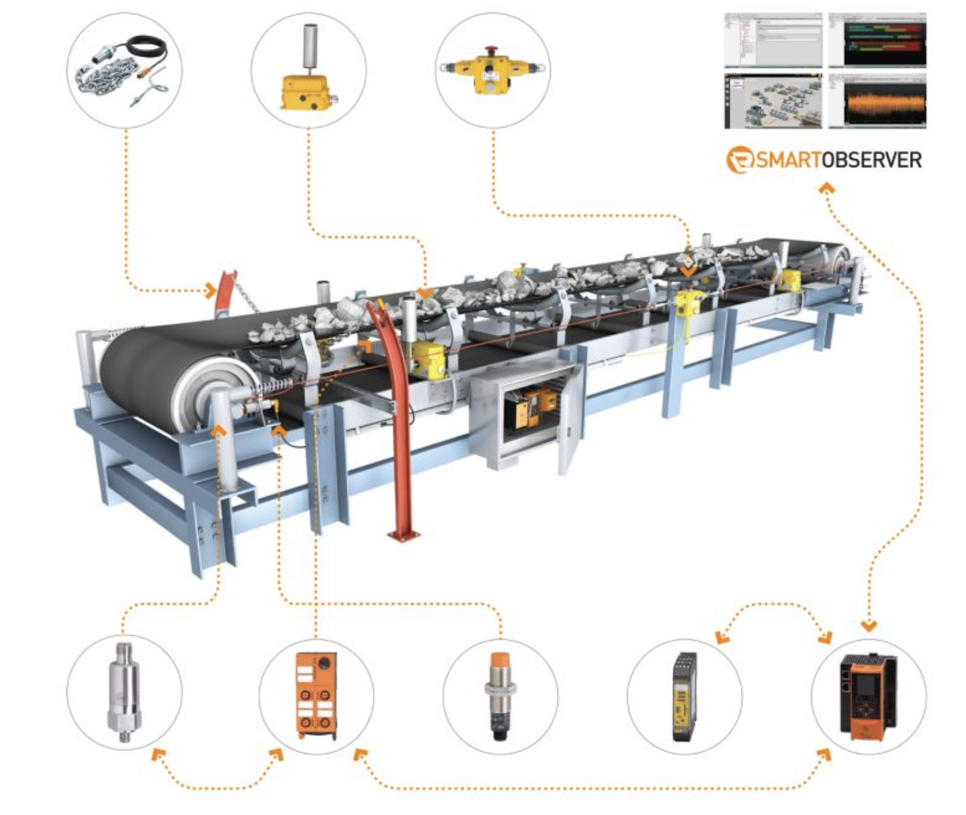

Shaeffler Optime

<https://www.schaeffler.es/content.schaeffler.es/pt/produtos-e-solucoes/industrial/portfolio-de-produtos/produtos-de-manutencao/optime/index.jsp>

Sistema de fácil instalação para monitorização de variáveis físicas. Sistema proprietário, para monitorização e identificação de avarias.

Necessário o pagamento de uma mensalidade.

**Manutenção Preditiva**

Pretende-se incorporar diferentes sensores de diferentes fornecedores para aquisição de várias grandezas físicas, relação entre as diferentes grandezas físicas, aplicação de algoritmos de Inteligência Artificial (**AI**) **e Deep Learning**.

Necessário digitalizar os equipamentos e a grandezas físicas necessárias a cada processo.

Digitalização da documentação dos diferentes equipamentos,

Acessibilidade dos equipamentos através da Cloud, Utilização de bases de dados em tempo real.

Desenvolvimento de uma aplicação flexível com suporte para diferentes tipos de **sensores conectados por WiFi ou Bluetooth**

**Manutenção Preventiva:**

Registo das intervenções

Planeamento de intervenções

Analise de causas das avarias -> Ajuste dos KM0

Registo e controlo do consumo dos fluidos (Água/Óleos)

**Manutenção Curativa:**

Redução dos tempos de intervenção, através do desenvolvimento de “**Bancada Móvel de Diagnóstico e Intervenção**”, para analise de diferentes grandezas físicas: Temperatura, pressão, caudal, vibração, consumos de corrente elétrica, visão termográfica

<https://www.fluke.com/pt-pt/produtos/camaras-de-imagens-termicas>

Gestão Inteligente dos Stocks, rastreando a rotatividade, ajustando as quantidades mínimas em função das necessidades.

## Variáveis a adquirir:

- Pressão

- Caudal

- Temperatura

- Vibração

- Consumo elétrico

- Visão

- Sensores WiFi

Alguns sensores tipo e Softwares de aquisição:

- Shaeffler

- Optime

- Smartobserver